**Full Structure Code**

1. *Possible automations have been done in the Post processing side (****Structure is complete****)*
2. *Gait parameters from one of the references is used and dataset is synthetically generated*
3. *Time computation is noted*

**File Name: Gait_para_ext_v2**

1. Loading the files having 4 scenarios:

* Normal_10
* CB_10
* Normal_20
* CB_20

Each joints of file are loaded as list and separately as *lis_x, lis_y* and *lis_z* coordinates respectively.

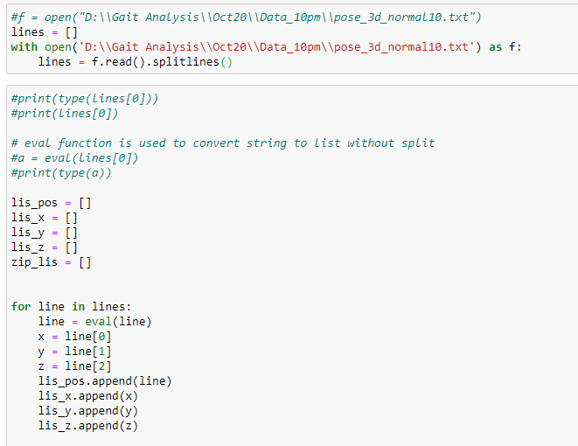

1. **Step length execution**

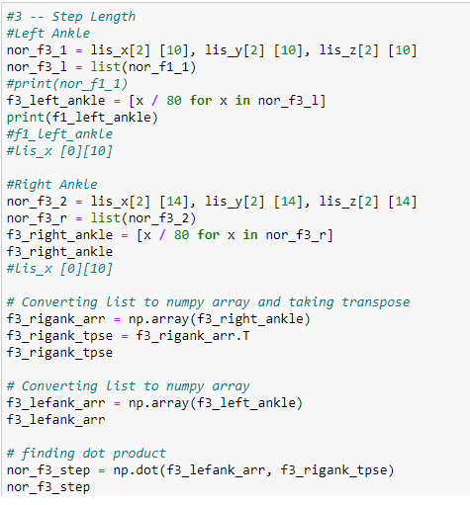

3. **Computation of Step width**

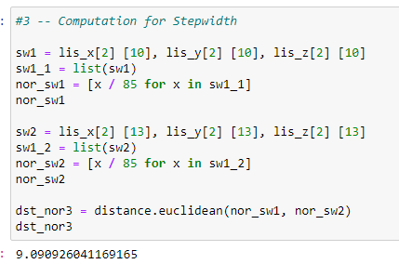

1. **Gait speed**

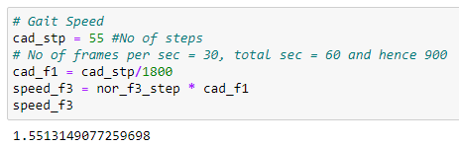

1. Determination of *Mean, Standard Deviation, min and max values* of Step length, Step width and Gait speed

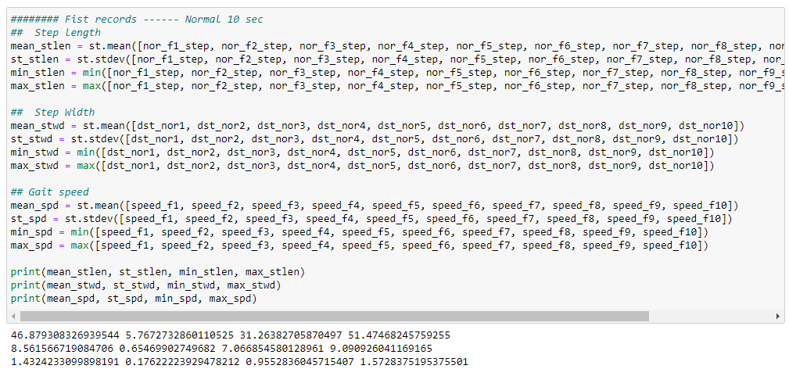

1. Similarly, values are extracted for Normal 20 seconds, CB7-10 seconds and CB7-20 seconds.

File: real_time_eval_v2

1. Reference values with Mean, Standard deviation obtained for Step length, Step width and Gait speed

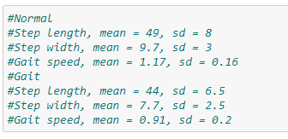

1. Generating dataset using Python for Normal records

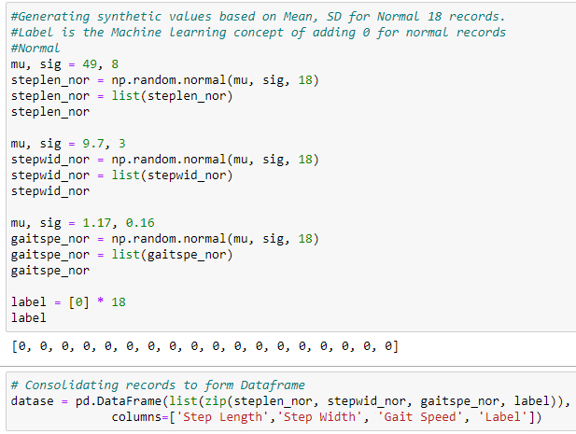

1. Generating dataset using Python for Gait records

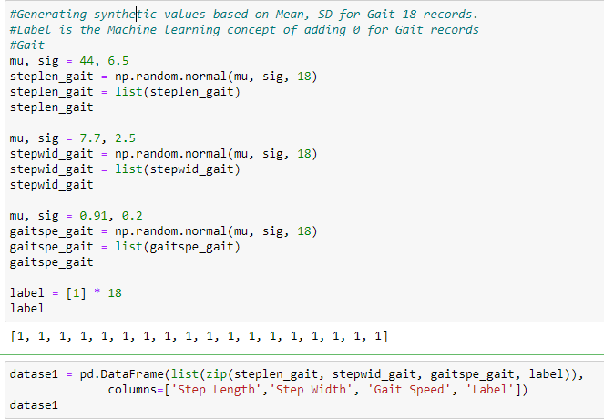

1. Dataset is consolidated as below

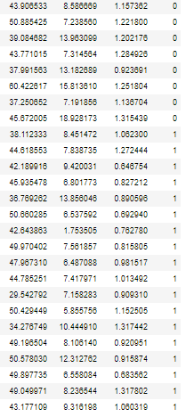

1. Splitting the training records into features and labels

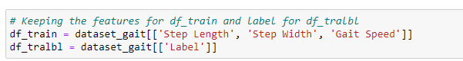

1. Taking the test values obtained from 4 cases: Nor_10, Nor_20, CB7_10, CB7_20

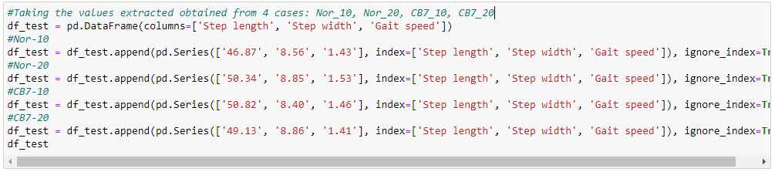

1. Extracting the model with Logistic Regression model

